
Week 3 - The five kingdoms of the living world
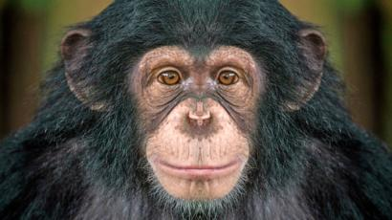
Kingdom Animalia: All organisms in this kingdom are multicellular. Each cell stores its genetic material in a nucleus but doesn’t have a cell wall. Animals gain energy from other living things. We belong in this kingdom. Zoologists are the scientists who study animals.

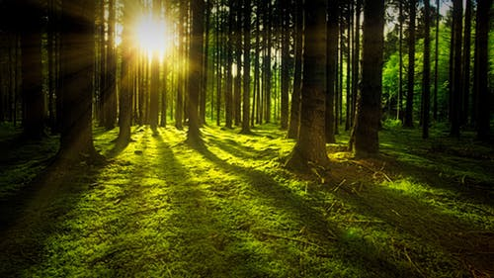
Kingdom Plantae: Plants include tress, vines, bushes, ferns, mosses, weeds and grasses. They all gain energy by making their own food from sunlight. They are multicellular and their cells have a cell wall around the outside of the cell, as well as a nucleus inside the cell. Botanists are the scientists who study the plant kingdom.
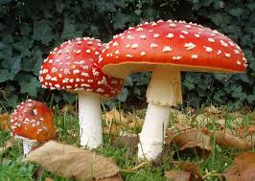
KingdomFungi: Includes mushrooms, toadstools, yeasts, puffballs, modulds and truffles. Some fungi grow in wood and in soil, and develop from tiny spores. Fungi store their genetic material in a nucleus and do not make their own food. Instead , they feed on the remains of dead animals and plants. Some fungi can cause diseases, such as tinea. Mycologists are the scientists who study Kingdom Fungi.

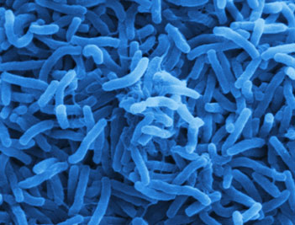
Kingdom Monera: This kingdom is made up of the simplest and smallest living things. There are approximately 75000 different organisms in kingdom Monera and they are all unicellular and have a cell wall but no nucleus. Bacteria are the most common in this kingdom. Many people think of bacteria as harmful to humans, but this is not always true. Bacteria in the soil break down rubbish and waste produced by animals. Without Bacteria, we would be surrounded by mountains of smelly rubbish. Bacteria is also used to produce some foods such as cheese and yogert. Microbiologists are the scientists who study microorganisms in kingdoms Monera and Protista.
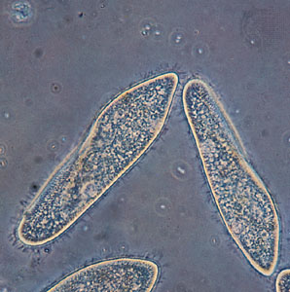
Kingdom Protista: There re approximately 55 000 species of protists. Their cell structure is more complex than that of monera. Often, organisms to much larger ones, like seaweed. They do all have one feature in common: they store their genetic material in a nucleus. Plankton, the tiny sea creatures eaten in their millions by whales, are part of this kingdom. Amoeba, microscopic organisms that change their shape to trap their food, also belong to this group.

Task 1 – Questions
Answer the questions below using the information above.
- Identify the different scientist that study each kingdom.

- Define the following words:
Multicellular –
Nucleus –
Cell wall –
Unicellular –

- Name four features that all animals have in common

- Name four features of kingdom fungi

- Name an organism made up of just one cell

- How is a protist different from bacterium?

- What is the difference between cells in kingdom plantea and kingdom fungi?

- Why was the invention of the microscope impotant to our understanding of living things?

Task 2 – Complete the table below using the notes above or the internet
Kingdom | One cell or many cells? | Drawing of cell with labels | What does the cell have? | How does the organism get food? | Example of organisms

Task 3 – Classification code

Each level of the Linnaean classification system is like a code that describes the way an organism looks or behaves.

Kingdom – broken up into 5 groups (today we are mixing Monera and Protista into one group)
Animalia – has many cells with a nucleus, is able to move freely from one area to another, needs to eat nutrients and gives birth to live young.
Plantae – has many cells with a nucleus and cell wall. Although it can move one part of its body, it usually stays in the one place. It uses photosynthesis to makes its own food (it has green chlorophyll) and has seeds.
Fungi – usually has many cells with cell walls, needs to eat its nutrients, has spores instead of seeds and usually does not move from place to place.
Monera/Protista – monera – single cell, Protista single or more cells. Has cell walls. Examples bacteria, ameobas, plankton, seaweed

Follow these instructions to identify the kingdoms the pictures belong to. Fill in the names on the table on the next page.

- Separate the green plants. These are the plantae group.

- Separate the animals. These are animalia group.

- Separate the mushrooms. These are the fungi.

- The remainder will fall into Monera or Protista.

- Record which Kingdom each picture falls into.

- Try to label the common name for the animalia and plantae.

Table 1.0 Kingdom Classification

Picture | Kingdom | Common Name
a
b
c
d
e
f
g
h
i
j
k
l
m
n
o
p
q
r
s
t
u
v
w
x
y
z
aa
bb

- 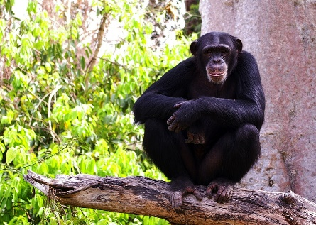 e. 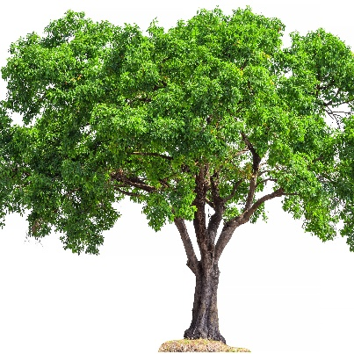
- 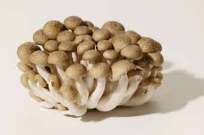 f. 

- 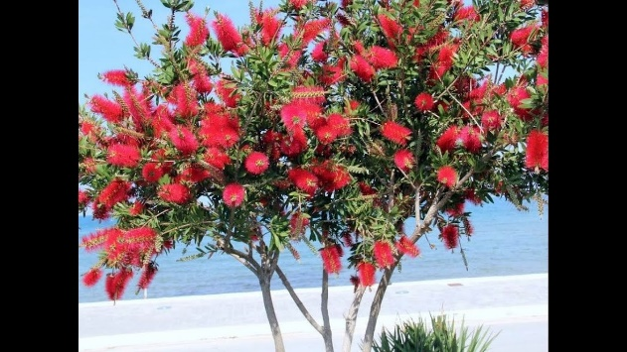 g. 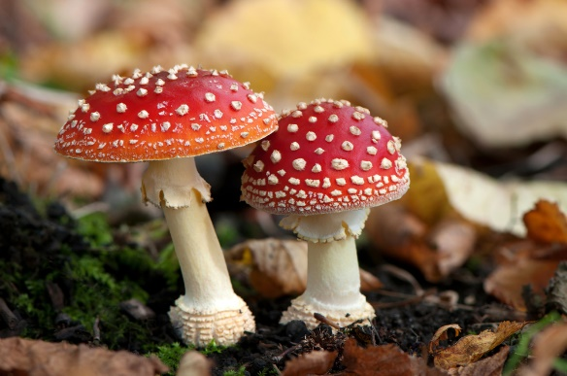
- 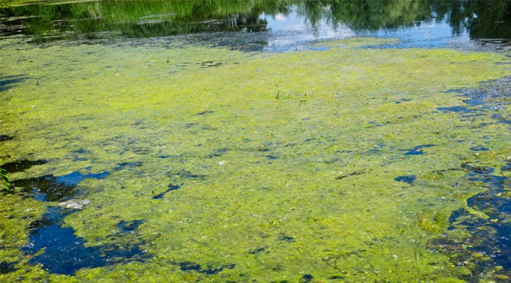 h. 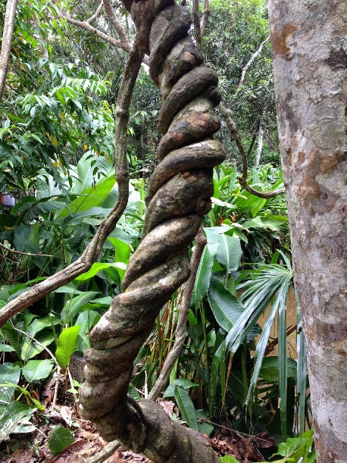

- 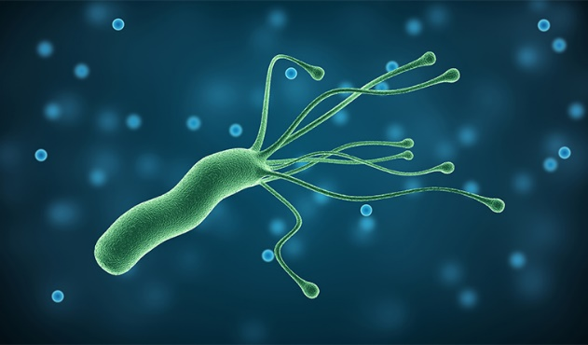 m. 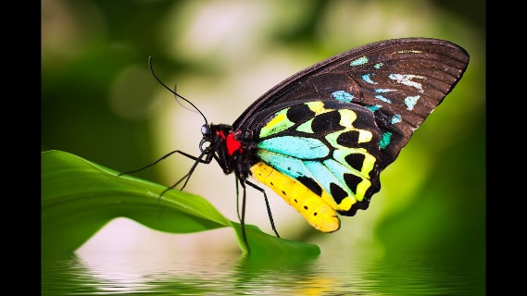

- n. 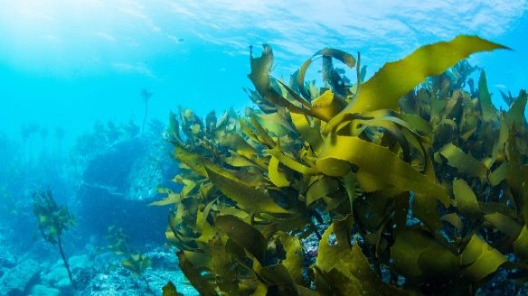

- 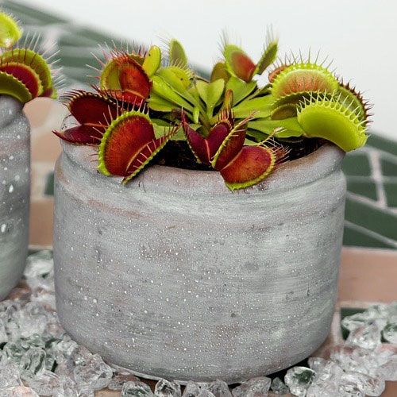 o. 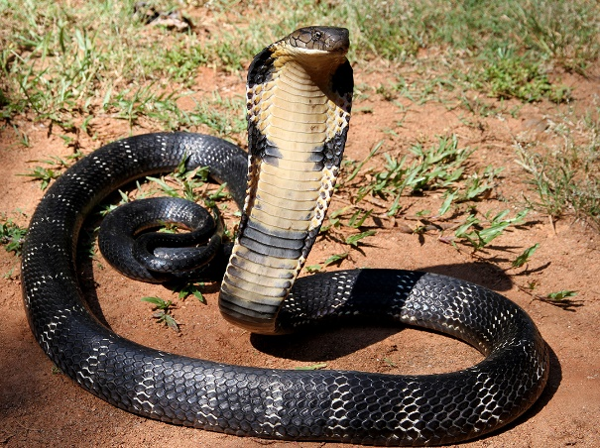

- 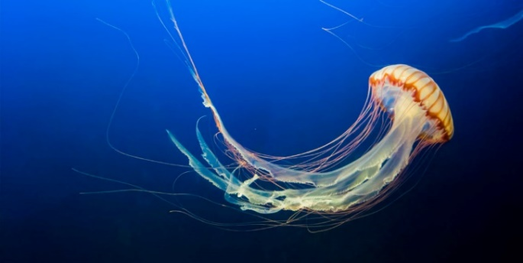 p. 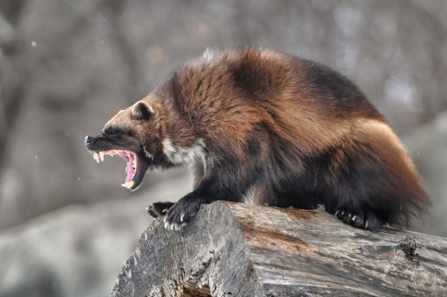

q. 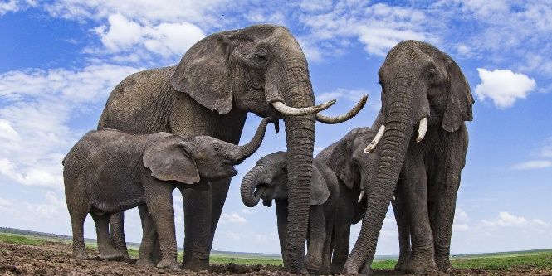 u. 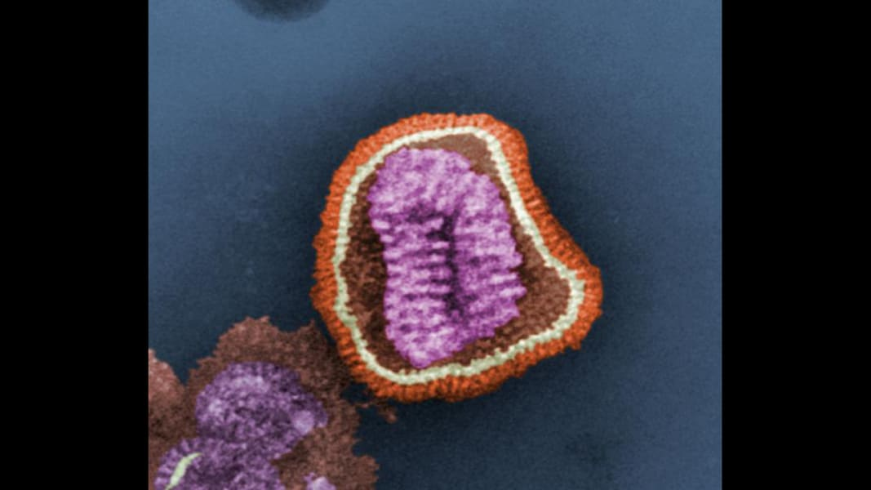
r. 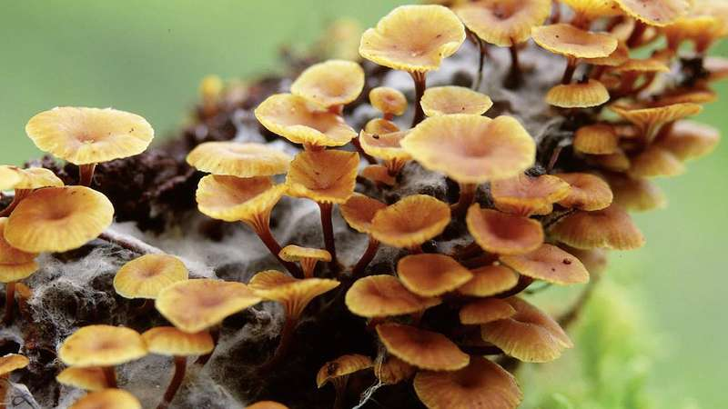 v. 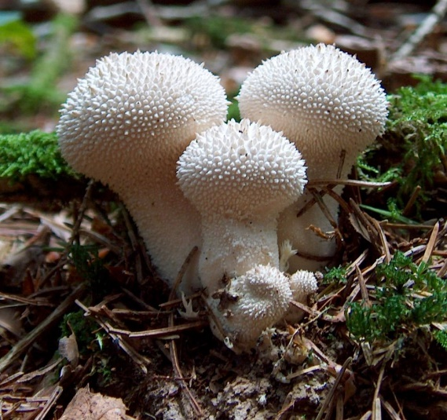
s. 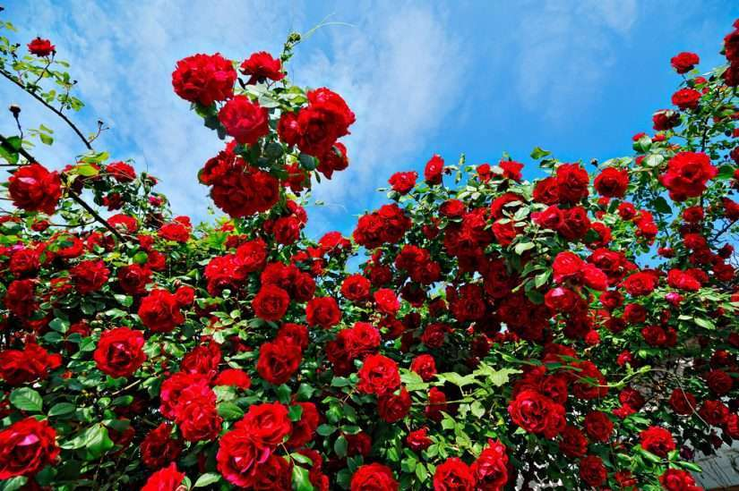 w. 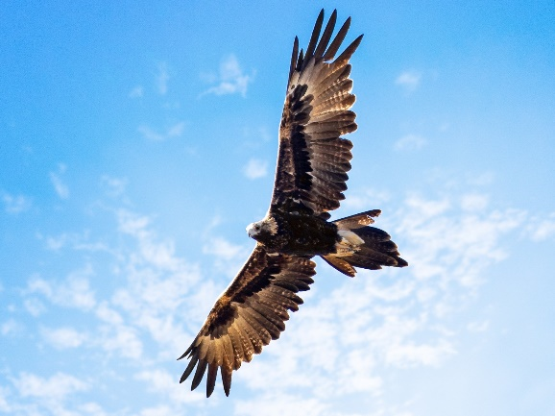
t. 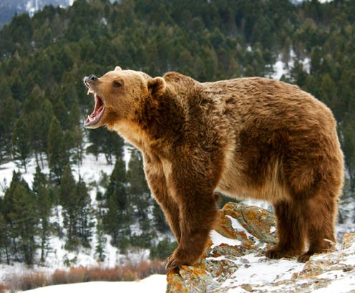 x. 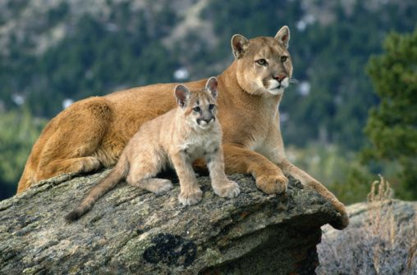

y. 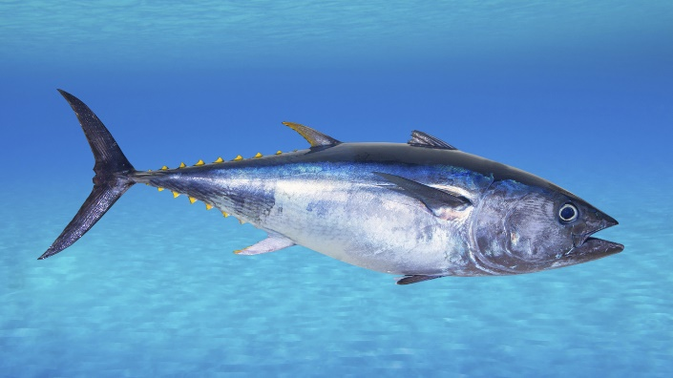

z. 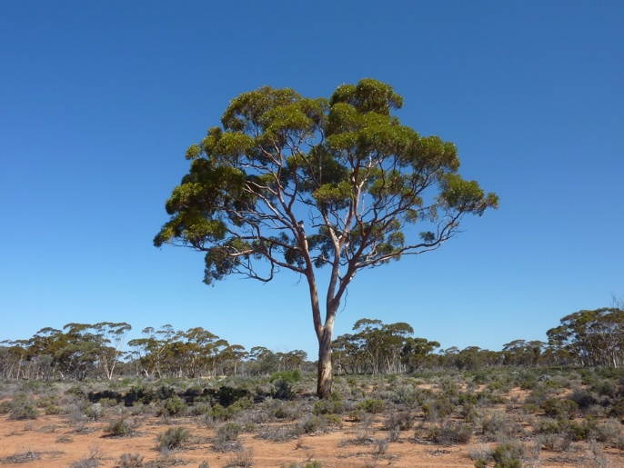

aa. 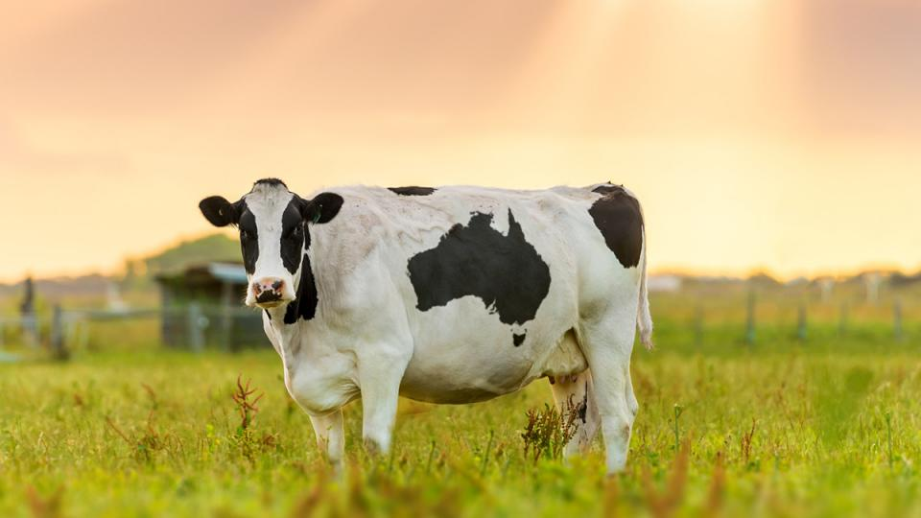

bb. 

Task 4 – Vertebrates and Invertebrates

In the same way as when creating and kind of dichotomous key, dividing the animal kingdom into groups first requires a question. The system scientists use to divide animals into groups is based on their structure. The question is, ‘Does this animal have an internal or external skeleton?’
Animals such as dogs, humans and birds with an internal skeleton (called an endoskeleton) are put in a group called vertebrates. Because these animals often have a spinal cord that threads its way along the vertebrate bones, the phylum is called Chordata. Other animals with an external skeleton (exoskeleton), such as beetles and crabs, and those with no skeleton at all, such as slugs are known as invertebrates. 96% of all animals are invertebrates!

Activity
Use the key to identify these invertebrates, if you are finding this difficult watch the invertebrates video to help you
1 | Body spongy, with many holes | Poriferan
 | Body not spongy | Go to 2
2 | Soft body, no shell | Go to 3
 | Outside or hard cover | Go to 6
3 | Many tentacles or arms | Go to 4
 | Long body without tentacles | Go to 5
4 | Tentacles around the mouth of a sac-like body | Cnidarian
 | Arms with suction discs | Mollusc
5 | Soft body, large foot | Mollusc
 | Worm-like or leaf like | Nematode, platyhelminth or annelid
6 | Proper shell or smooth, hard covering | Go to 7
 | Spiny skin with rough covering | Echinoderm
7 | Limbs in pairs | Arthropod
 | Shell, no segments, large foot | Mollusc

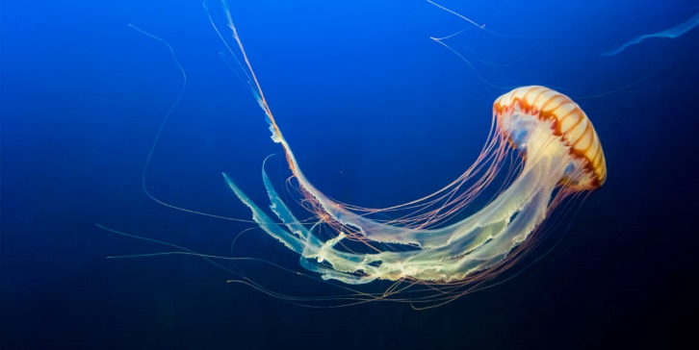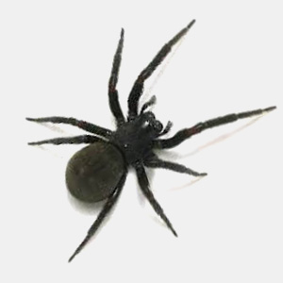

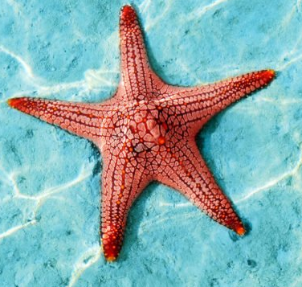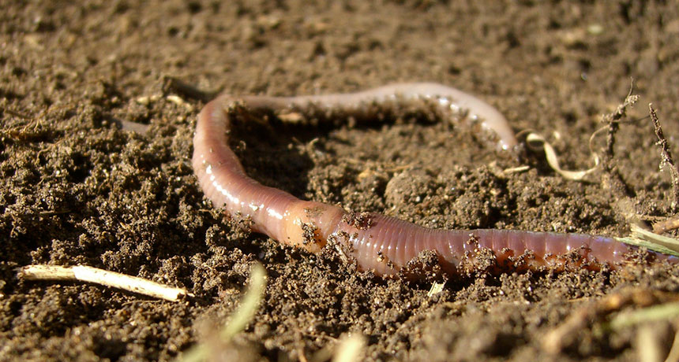
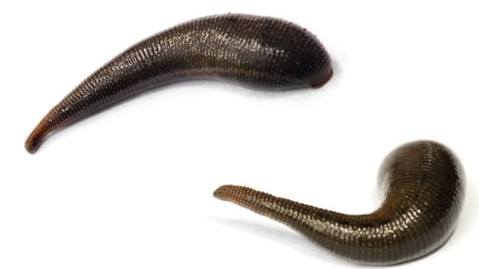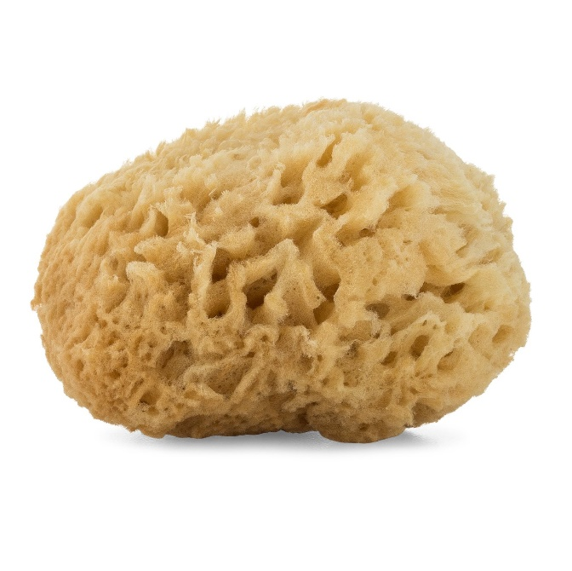

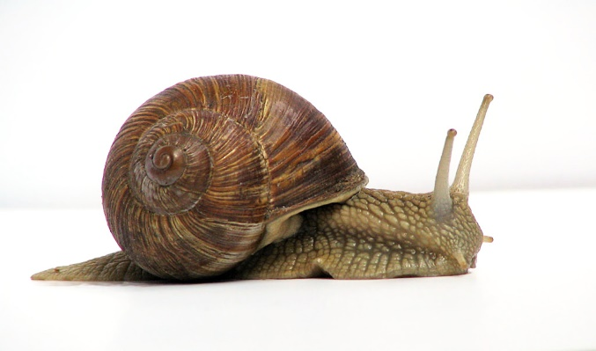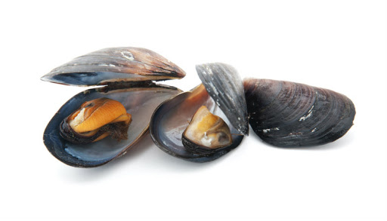
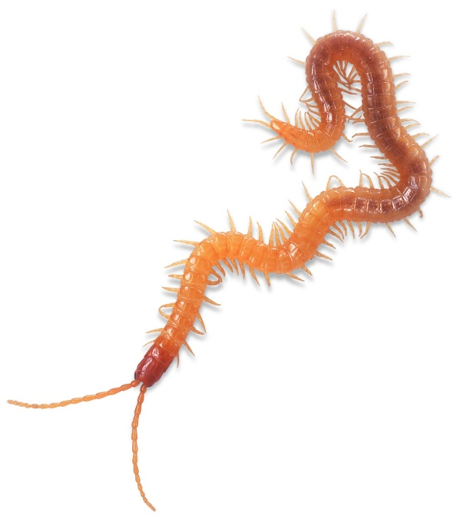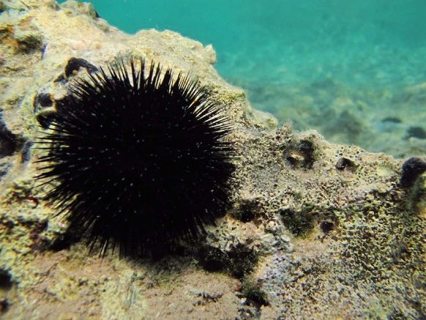

Task 5 – Classification of Dinosaurs

- In the space below list the different types and parts of a dinosaur.

- How would you classify dinosaurs?


Search

Research how dinosaurs are classified.

- Use the following website and explain how dinosaurs are classified in the space below.

https://www.enchantedlearning.com/subjects/dinosaurs/dinoclassification/

- Make a branching classification key for the following dinosaurs, include a dinosaur of your own choice.

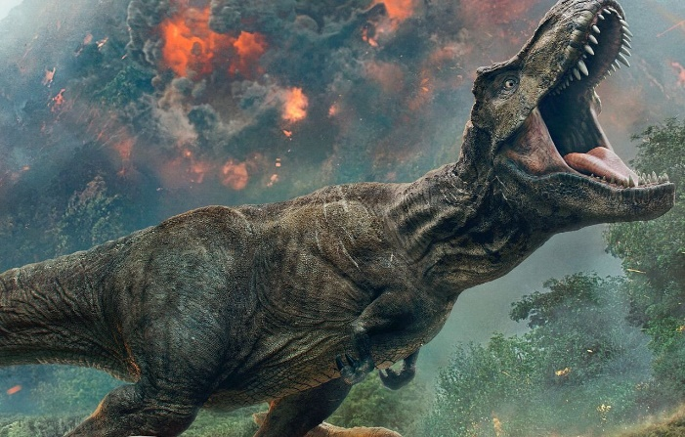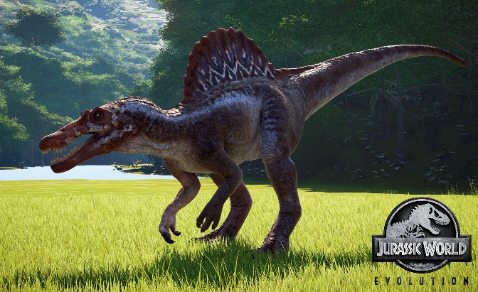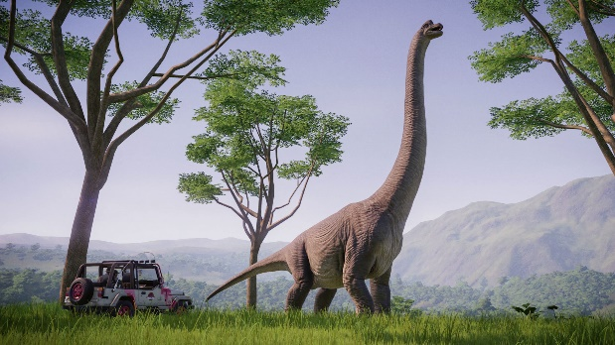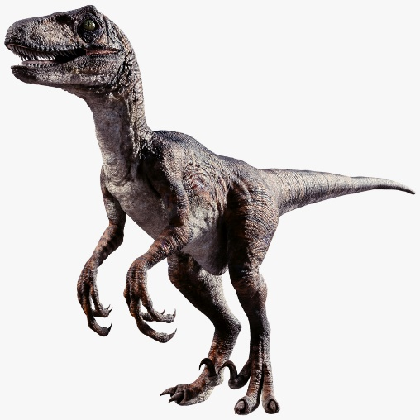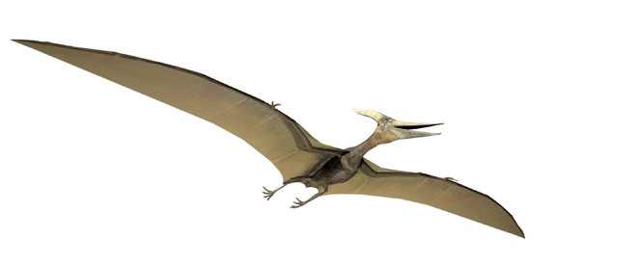

Cite

Why must I cite my sources?
- I cannot claim the work or ideas of someone else as my own
- Plagiarism is not just when I directly copy words from someone else's work. Plagiarism is also when someone else's work is paraphrased or their ideas are used and claimed as my own
- Referencing has a positive effect and adds credibility to my work
- When I reference correctly, I am demonstrating that (a) I have read widely on the topic and (b) that I am supporting my hypotheses with comments from expert authors and/or reliable sources
- Correct referencing allows the marker/reader to follow-up my references and check the validity of my arguments for themselves.

Surname | Initial | Title of page | Full title of website | Date Written | Internet Address | Date of visit
Brown | J. | ‘Things in Space’ | Astronomy Facts | 1998 | http://www.astronomyfacts.com | 31 July 2019

References:
https://www.shutterstock.com/search/monkey+face
https://www.pexels.com/search/green%20forest/
https://en.wikipedia.org/wiki/Amanita_muscaria
http://www.bacteriamicroscopes.com/
https://www.britannica.com/science/Paramecium
https://scopeblog.stanford.edu/2019/11/26/stung-understanding-jellyfish-stings/
https://forensicpestcontrol.com.au/pest-info/common-spiders-sydney/
https://www.muralswallpaper.com/au/shop-murals/orange-starfish-wall-mural/
https://www.sciencenewsforstudents.org/article/earthworm-invaders-may-be-stressing-out-some-maples
https://www.dailytelegraph.com.au/newslocal/northern-beaches/how-to-extract-a-leech-bloodsuckers-are-out-in-force-as-warm-wet-weather-creates-paradise-for-parasites/news-story/cf9729041a32d2d3e2e1352590321e02
https://captainblankenship.com/products/sea-sponge
https://en.wikipedia.org/wiki/File:Grapevinesnail_01.jpg
http://fishonfriday.org.uk/mussels/
https://www.dkfindout.com/us/animals-and-nature/invertebrates/centipedes-and-millipedes/
https://www.total-croatia-news.com/lifestyle/30060-sea-urchins-dalmatia-s-delicious-foot-stabbers
https://www.kuduhills.com/article.php?id=247#.Xoa8QYgzaUk
https://www.thoughtco.com/id-trees-using-leaf-shape-venation-1343511
https://www.artstation.com/artwork/3ooL1A
https://www.motionpictures.org/2018/05/its-a-t-rex-versus-a-lion-in-ferocious-new-jurassic-world-fallen-kingdom-spot/
https://static.turbosquid.com/Preview/2016/08/15__05_40_23/square1.pngCAADFB60-670E-4F7D-A482-9CF6DE52E3A8Zoom.jpg
https://dinosaurpictures.org/Pterodactyl-pictures
https://www.gamewatcher.com/news/jurassic-world-evolution-return-to-jurassic-park-release-date

